Creating a Task Management App Using HTML, CSS, and Firebase

Creating a task management website using HTML, CSS, and Firebase involves several steps, including setting up the Firebase project, designing the website's layout using HTML and CSS, and integrating Firebase for real-time database functionality. Below is a detailed tutorial to guide you through the process:

Setting Up Firebase

1. Create a Firebase Account: Go to the Firebase website (https://firebase.google.com/) and sign in or create an account if you don't have one.



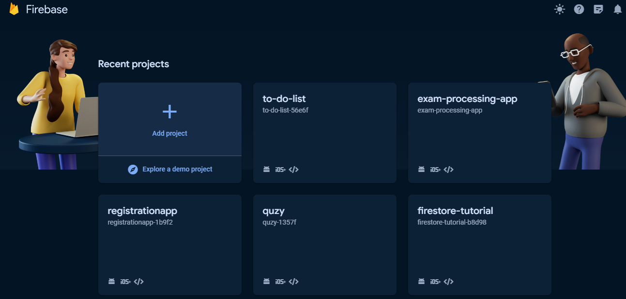

Setting Up Authentication

Under the "Build" Click on the "Authentication" Tab. After this click "Get Started" and choose you various authentication services you want to intergrate in the app. For our scenario we will be using "Email/Password".
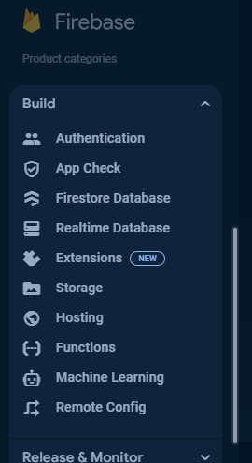

In your Firebase project dashboard, navigate to the Firestore Database section(Which is under the "Build") and click Create database".

After Navigating to the Firestore Database Click on "Create Database"



Choose the Location for your Database
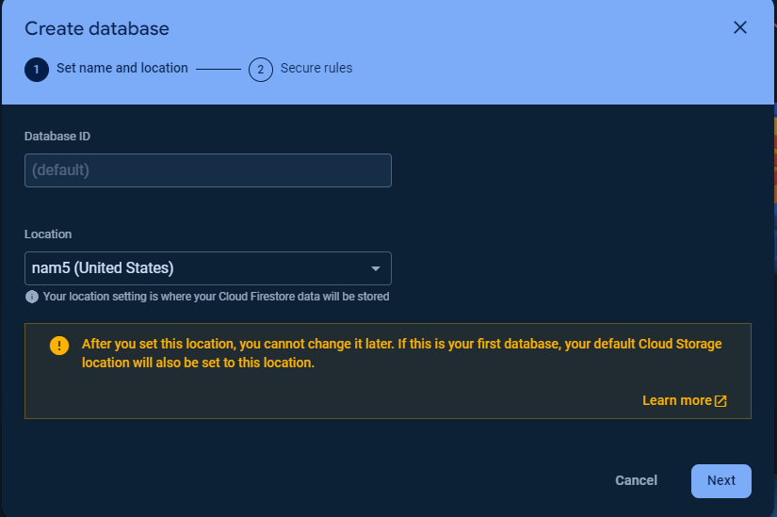

Choose the Mode. It is advisable you choose "test mode" for the time being
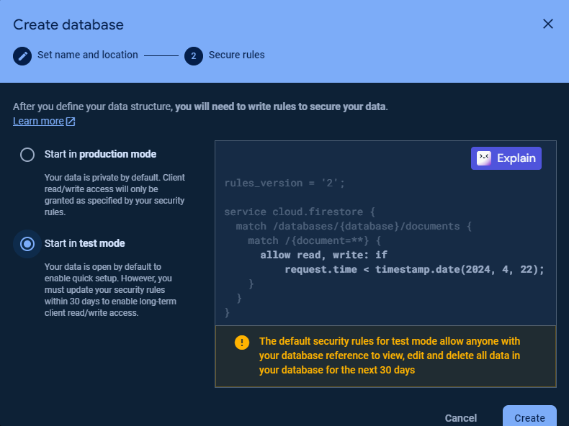

After successfull firestore setup you should have the Following view
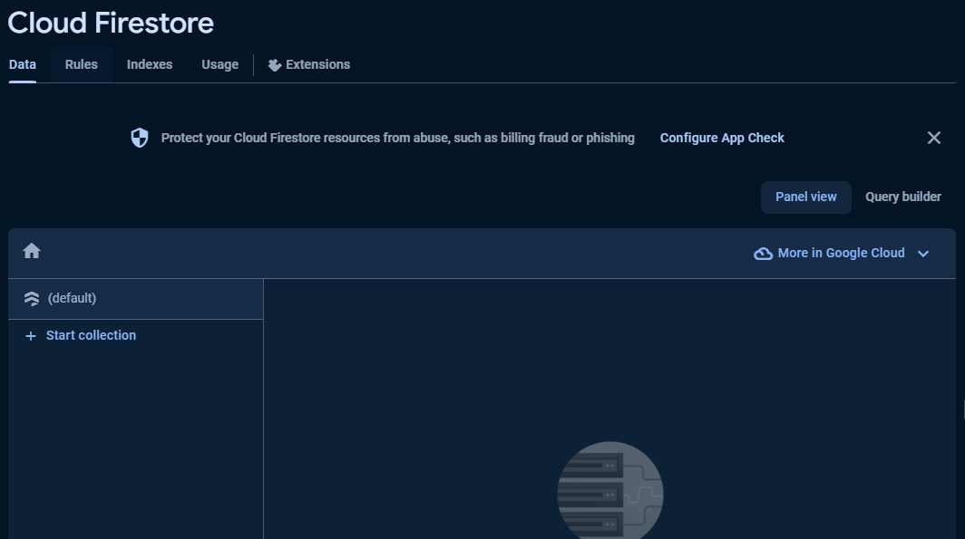

4. Get Firebase Config: On the Project Overview click on "add app". Then choose web, the one with this icon "</>". It will take you to a screen as shown below:
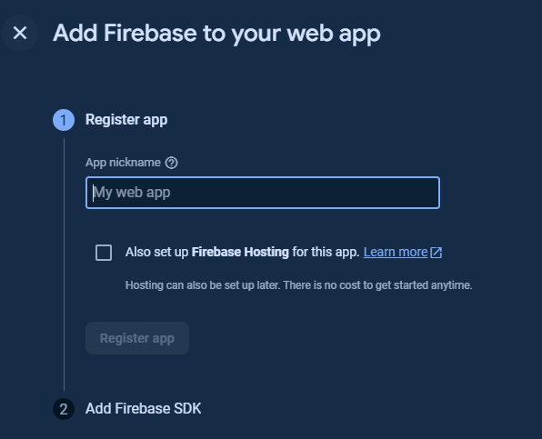

Add you App Nickname and then click "Register", then choose "Use a <Script> Tag> then copy the code in there then click "Continue to Console" Button
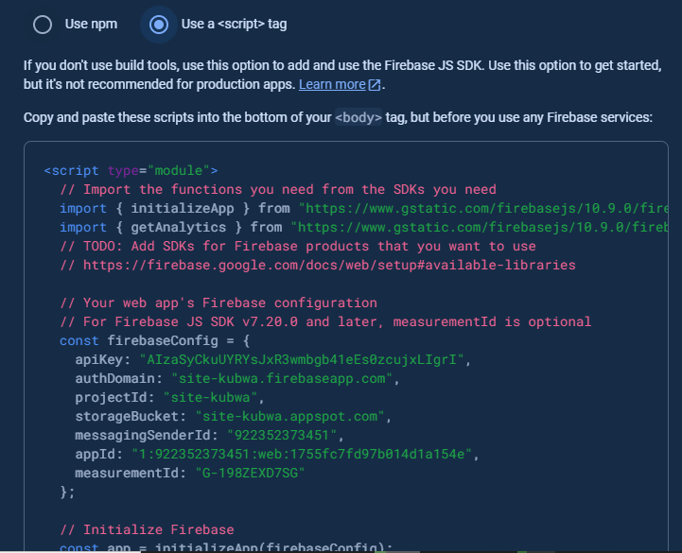

Congratulations you have successfully added your app to Firebase.

Creating The HTML for our Task Management Website

Create an HTML file (`index.html`) and set up the basic structure:
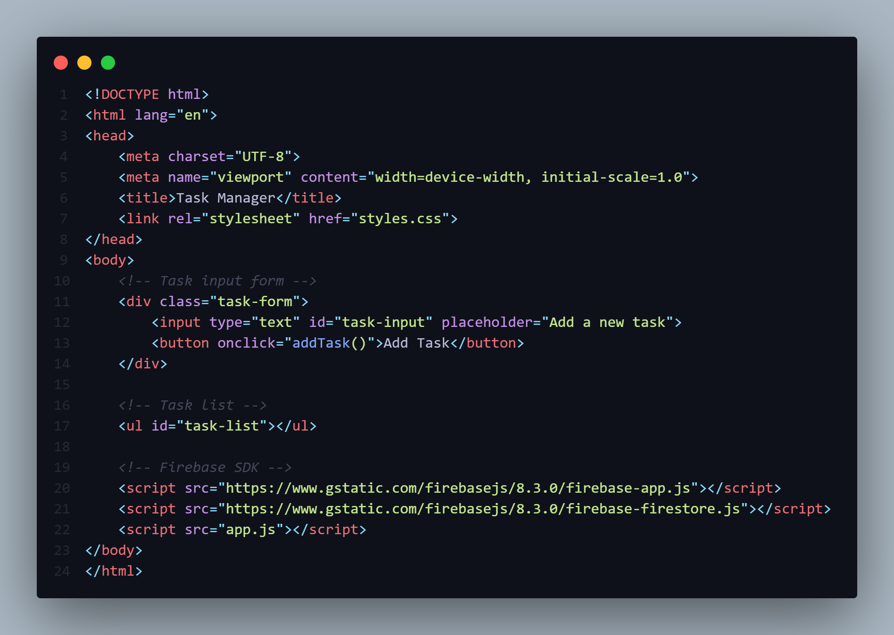
Create an HTML file (`index.html`) and set up the basic structure:

Styling our Website

Lets apply some styling to our App now: File name is style.css:

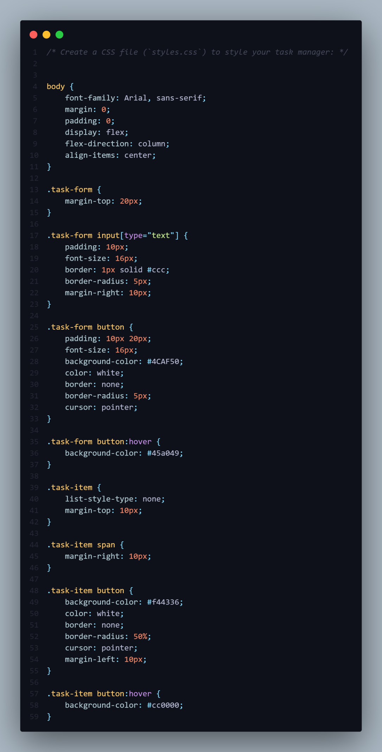
JavaScript Functionality

Create a JavaScript file (`app.js`) to handle Firebase integration and task management functionality:
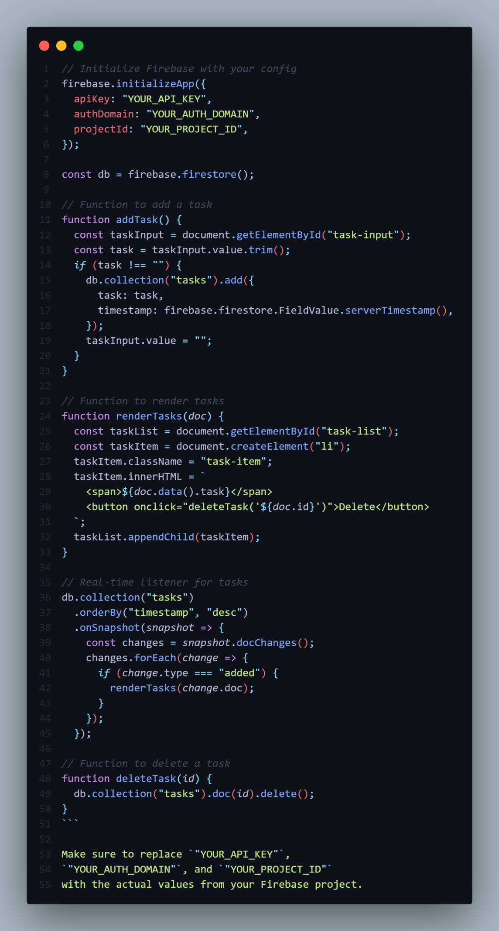
Hosting Our Website

Once you've completed the development process, you can deploy your website. Firebase offers hosting services as well. Install the Firebase CLI tool, initialize your project, and deploy:
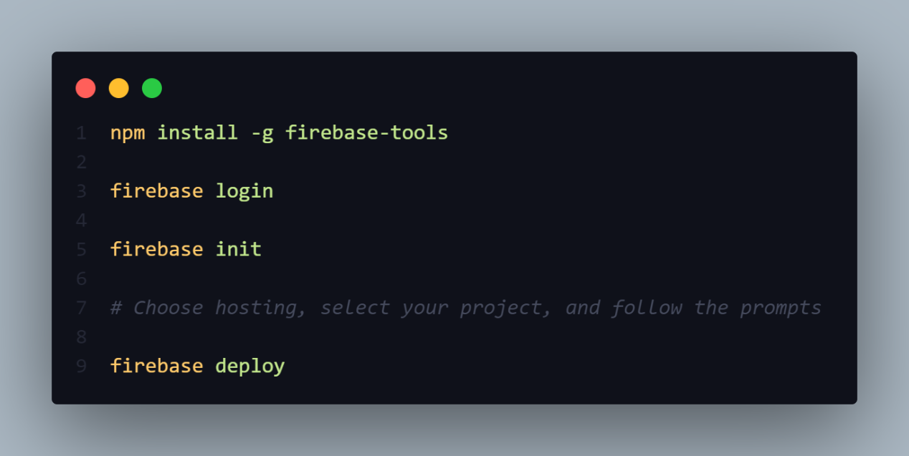

Your task management website should now be live!

Conclusion

By following these steps, you've created a simple task management website using HTML, CSS, and Firebase for real-time database functionality. You can further enhance this website by adding features like user authentication, task prioritization, due dates, and more.

